**Branching Strategy**

* Git Flow: <https://directdevops.blog/2019/01/04/best-branching-strategy-git-flow/>
* Trunk based development: <https://www.atlassian.com/continuous-delivery/continuous-integration/trunk-based-development>
* Also refer the following branching strategy
  + Gitlab
  + GitHub

**Pull-request**

Consider this original repository <https://github.com/GitPracticeRepo/prdemojuly23>

In the pull request, we will fork/clone changes for any repository, and later create review with owner to merge those changes.

Pull request is basically a flow where we push the changes for verification before we commit.

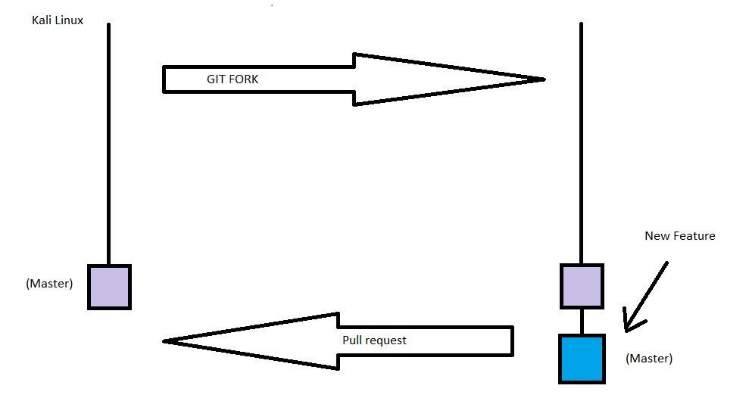

**Workshop – Project**

* Project <https://github.com/nopSolutions/nopCommerce>
* We will create a pull request based workflow  
  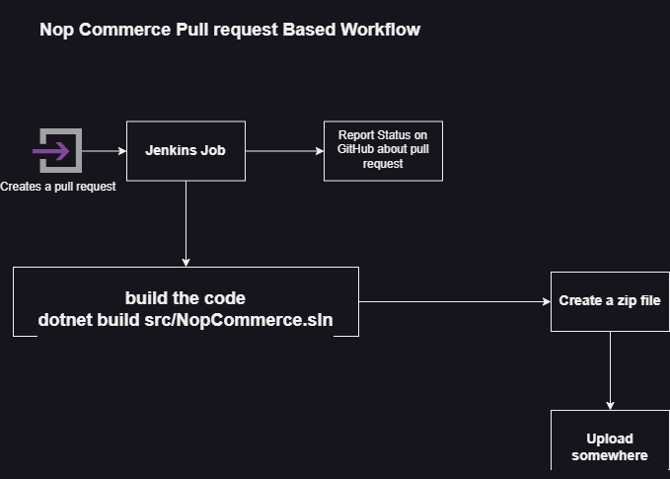
* Release Branch (Night build)
  + Docker/Container based workflow (DevSecOps)
    - Security Scans
      * SCA
      * SAST
      * DAST
    - From terraform
      * Kubernetes cluster
      * Deploy application
  + VM based Workflow
    - From Terraform
      * VM
      * Database